HOTEL INFORMATION

Holiday Inn Express  (903)657-5250  300 Kilgore DR. Hwy 259 North  Single Room: $125.00 Double Queen: $125.00  Please refer to the website for more info  http://holidayinnexpress.com/hendersontexas | 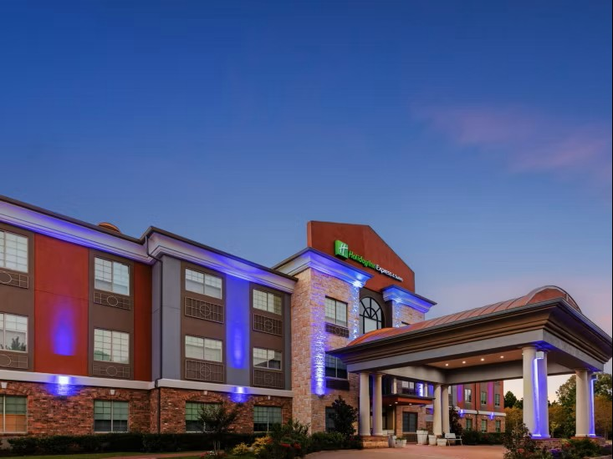
Baymont Inn  (903) 657-7900 - 410-Hwy 79 South  Room block offering: 10 rooms August 1-3  King Rooms: $109.00 Standard Queen: $119.00  Hot Breakfast  Free High-speed and Wireless Internet in Lobby/guestrooms.  baymonthehenderson@gmail.com  Reservation by 07/18/2025 | 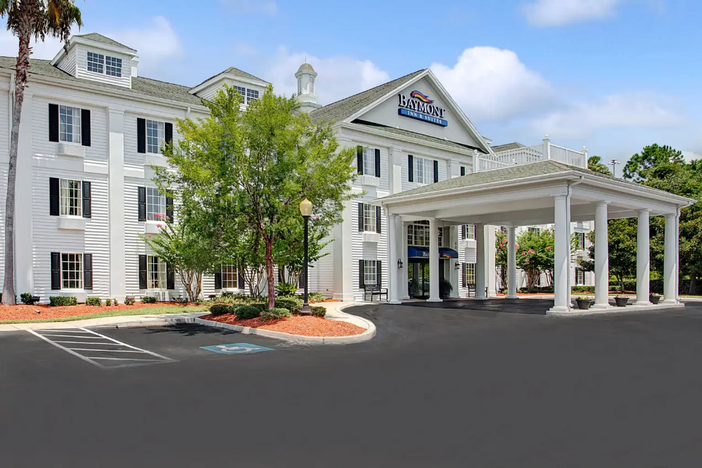
Motel 6 (903)392-8861  1500 US Hwy 259 South  (formerly Best Western)  1 King:( $61.19) per night Double Room: ($66.95) per night  All Reservation by July 25. 2025  Free WiFI, No Breakfast offer/Hot Coffee | 