Hill High School Alumni Association
Officers  James Redwine  President  Lonnie Fields  Vice President  Bernice Murphy  Secretary  Marva Jones-Webb  Assistant Secretary  Alverstein Hightower  Treasurer  Mary Bradley-Alexander  Financial Secretary | 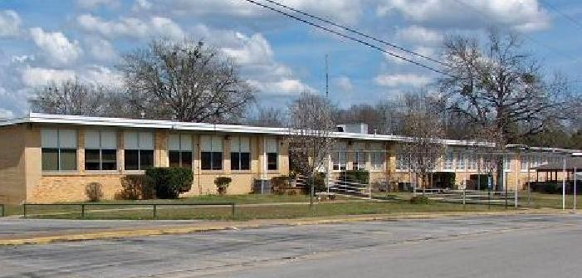 | Trustees  George R. Burnett  Alvestein Hightower  Joan Massey-Carver  Seretha Thompson Merchant  Rayford Shaw

Dear Fellow Alumnus,

Do you know what time it is? It’s reunion time, “REUNION 2025” to be exact. We hope and pray all is well, and you are making plans to be in Henderson, Texas, August 1-3, 2025. Plans are in the work for a grand time, the calendar has been set.

If you are planning to be a candidate for office in Hill High Alumni Association, don't forget to obtain a Nomination Form from your local chapter or log on to www.hillhighalumni.org to
print a copy, complete and mail by June 15, 2025.

To: Patsy Ballenger-McCoy
2204 Martin Luther King Dr.
Henderson, TX 75652

