**ADVERTSER REQUEST FORM**

**HILL HIGH SCHOOL REUNION 2025**

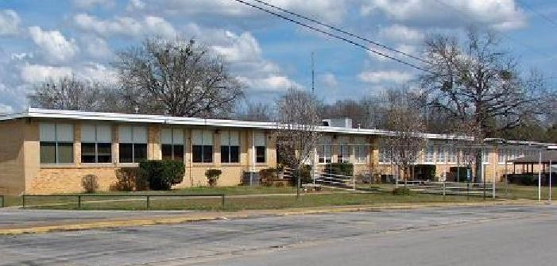

I__________________________________, wish to Purchase a_________________Page Ad for my business to be included in your souvenir booklet. I have enclosed my Ad, business card and/or other written wording that I want printed in the booklet.

**\*Note:** Make sure the document that is being sent is good and clear.

|  |  |  |  |
| --- | --- | --- | --- |
| **Ad Type** | **Price** | **Picture Option** |  |
| **Outside Back Cover** | **$300** | **None** |  |
| **Inside Cover** | **$200** | **None** |  |
| **Full Page** | **$150** | **Available** | **$10** |
| **Half Page** | **$75** | **Available** | **$10** |
| **Quarter Page** | **$45** | **None** |  |
| **Eighth Page** | **$25** | **None** |  |
| **Patro Listing** | **$15** | **None** |  |

**Please print your advertisement below or attach a business card**

**\*Note:** Make sure the document that is being sent is good and clear.

_________________________________________________________________________________________________________________________________________________________________________________________________________________________________________________________________________________________________________________________________________________________________________________________________________________________________________

Send payment to Mary or Bernice.